Code Review: I2308099
Reviewer: Mark Dell
Date: September 15th, 2023

Bugs

Preventative Action/Safety

Design/Architecture (Duplication, appropriate project, namespaces, maintainability)

Data Model (Naming, good design, needs index?)

Performance (Minimize DB hits, excessive loops, queries, scalable)

UI (Alignment, naming, standardization, tab order)

Error Handling (Behind events, appropriate parameter checking)

Cleanup (Dispose code, remove handlers, large data objects)

Readability (Well-named variables, methods, clear algorithm, is it understandable)

Comments (Useful, explains why rather than how)

Message Boxes (Grammar, spelling, captions, appropriate icons)
- Better wording can be used in the message boxes that are displayed.
“No lines have been included, therefore none will be cancelled.”
“Would you like to cancel the selected work order lines?”
- While the titles are slightly different, they should be closer to the actual topic:
“Cancel Work Order Lines”.
- We use the  icon when asking a question, even though Microsoft recommends against it.
I also recommend the  icon, in this case, for the notification message instead of the exclamation (warning) icon.
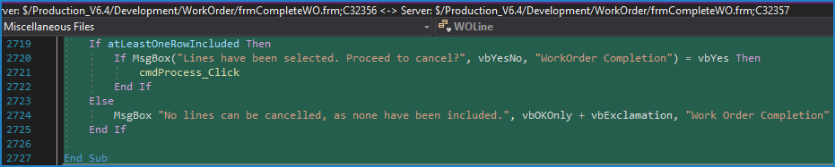

Ticket Management (Release Branch?, Testing Notes)

Extras
- Nit: Legacy coding style: We never use the return value of the Farpoint Spread methods like GetInteger unless absolutely needed.
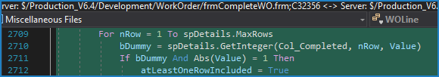
- Minimizing designer and code changes: VB6 often unnecessarily moves controls in the designer section of the file, and/or alters the binary file as well by adding junk data that shifts the positions of valid data. Often resaving the frm file, possibly including viewing the form UI, 1 or two times, can reset the designer and frx file back to having no changes other than those that you intended. This would also allow you to correct automatic case changes that you did not make (if you had any) at that time (Example steps to correct an automatic case change to “value” (from “Value”) made by the IDE: 1. Add “Dim Value”. 2. Leave the line. 3. Remove that code from step #1. 4. Save the file.)
-> Only modify to eliminate unintended changes, while minimizing designer and code changes from the current version.
I also noticed some controls had their Left and Top properties changed. Was that intentional?
